Spiritual Awareness - Blog

MT: Awaken Your Life: Embrace Spiritual Awareness and Healing
MD: Explore spiritual awareness, energy healing, and distant Reiki to transform your life. Start your journey to peace, balance, and inner fulfillment today.

Keywords
spiritual awareness
energy healing courses
distant reiki healing

WC: 1754

“Awaken Your Power: Master Spiritual Awareness, Energy Healing & Distant Reiki”
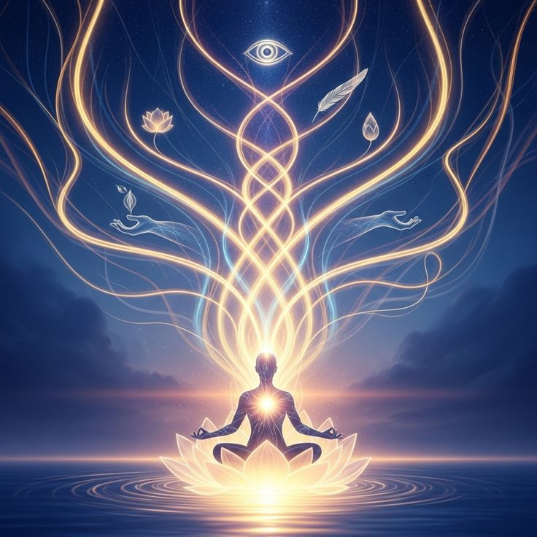

Are you feeling as if something is just not there? You are now stuck within the grind. Are you chasing after goals that seem to bring just temporary satisfaction? Deep down, you know life offers more peace with balance. You also know that you can connect more to your true self now. The good news is you have no need for a far search. It’s all within you. It waits right there in order that it can be awakened.

Deeply, spiritual awareness, energy healing, and distant Reiki are strong practices that can transform your life. They are not just for people seeking a mystic path; they are for all who look to regain calm in their lives, who grow inner peace, and who tap into self-understanding. This self-discovery adventure is something for you if you want joy, clarity in chaos, or to heal wounds.

This blog explores these practices and their power to awaken transformation in you. Ready to begin?

Spiritual Awareness: Awakening to Your True Self
Tuning into your higher self, as well as understanding life's unseen aspects around defines spiritual awareness. It’s realizing you do not move a physical body just through the world, but exist as a spiritual being with a purpose that far exceeds the day-to-day hustle.

What Is Spiritual Awareness?
At its core, spiritual awareness is becoming aware of everything within the universe, along with your connection to the universe. Realizing that your thoughts, emotions, and actions are linked to the energy around you is what it’s about. You begin to realize that everything does have a meaning. Each moment, as well as every experience, also has meaning.

How Does Spiritual Awareness Transform Your Life?
Nurture inner wisdom and exist purposefully. Then life starts occurring on purpose. Picture feeling grounded daily in your life, not anymore stuck inside sorrow or fear. Rather, you are grounded in the moment because of your trust that everything is unfolding in the way it should. Understanding allows you to proceed with a sense of calm and coherence through life.

Picture, for example, a stressful and overwhelming situation in which you were caught. With increased spiritual awareness, you learn that you have the ability to pause, take a breath, and react from calmness rather than responding from a place of panic.
Practical Steps to Cultivate Spiritual Awareness:
You can start with only five minutes a day, just quieting your mind using meditation. Try to become aware of any sensations or thoughts that do arise, plus focus upon your breath.

Mindfulness: You must pay attention to the present moment in time, whether you walk, eat, or simply breathe now. Notice all the sights along with the sounds surrounding you then. Consider any and all of the feelings that surround you now.

Journaling: Involves the recording of everyday thoughts and feelings. You can also connect to your intuition and your personal spiritual development.

Energy Practices: Such as yoga or Tai Chi, align your mind and body with your spirit.
When spiritual awareness is part of your daily practice, you will experience more alignment with who you are and what you are looking for.

Energy Healing Courses: Discover the Inner Healing

Energy healing is an interesting practice that works with the body's natural ability to heal itself. Energy healing is based on the understanding that everything about us is energy, our bodies, the foods we eat, the air we breathe, and our thoughts. When energy is stagnant or unconsciously out of order in our lives, that can lead to emotional, mental, or physical disruption; energy healing assists with this.

What are Energy Healing Courses?
Energy healing courses are designed to teach you how to access and work with this universal energy, so you can return to your childlike state of being in balance and harmony again. It doesn't really matter whether you are looking for opportunities to heal or exploring things to do as a healer for other people; you will learn and continue learning essential skills to help you unlock your full human potential.

For example, many people attend energy healing courses and workshops because they would like to practice Reiki, the most widely known technique, which is an energy healing technique of transferring healing energy through the human hands into the body, mind, and spirit to promote healing. If you study the fundamentals of energy healing, you will develop lifetime skills, tools, and techniques that you may utilize to work through emotional blocks, alleviate anxiety, and even address or eliminate physical pain.

Reasons to Attend an Energy Healing Course?

Personal Transformation: You will gain access to your own healing powers, support personal life balance, and your spirit's evolution.

Empowerment: When you learn to flow with an energy course, it will help you know how to heal yourself and even others.

Certification: Numerous energy healing courses also furnish participants with a certificate upon completion, which you can use for certification to work nominally as a healing practitioner.

Common Energy Healing Techniques You Can Learn in Class:

Reiki: A method of healing from the Japanese tradition that uses life force energy poured in through the hands.

Pranic Healing: A method of healing that removes obstructions and brings energy back into the body.

Crystal Healing: An approach that creates balance and alignment between energy fields and the body, using the energy of crystals.

Sound Healing: A process of healing the body’s energetic field with sound waves using gongs, tuning forks, and singing bowls.

When you take an energy healing course, you do not just learn a technique; you learn a whole new way of being and being in the World. Spiritual awareness increases when a higher perspective becomes visible. It is a process of self-discovery that will support you in opening healing, peace, and wisdom from deep inside you.

Distant Reiki Healing: Healing Beyond Physical Presence
Distant Reiki healing is perhaps the most awe-inspiring aspect of Reiki, where someone, in this case, you, can send healing energy to someone else instead of being there in person. You may be wondering: "How is that possible?" Well, this is about energy and consciousness. Energy does not have the same physical limitations your body does, meaning it can travel through space and time!

What Is Distant Reiki Healing?
Distant Reiki is the practice of delivering healing energy to another person who may be far away, sometimes thousands of miles away. This could be anyone from a loved one living in another country, to a client (or someone else) who has contacted you for help regarding a physical health concern, or yourself, wanting to receive relaxation or comfort. While a person may not be physically present, distant reiki can heal a person across physical borders, regardless of where the person heals. The healing intention of the healer on the energizing process to the one who is receiving the energy is the same, regardless of distance.

How Does Distant Reiki Work?
Practitioners of Reiki hold the belief that everything in the universe is connected through energy. When a practitioner joins and connects to the energy of Reiki, they are sending vibrational energy to another person for healing. The person will feel that the energy is being sent as if the healer were physically present in the space with them or that somewhere they are being included in the sessions. It is about trusting the treatment and believing and intending to receive energy.

In a typical distant Reiki session, the healer will ask for some basic information about the person receiving the treatment, such as their name and contact information, and location, and they may also ask if the person wants to share a specific issue to address. The practitioner sends the Reiki energy to the person with various visualization and energy techniques, and the recipient often reports feeling deeply relaxed, emotionally released, and even recovered from physical discomfort or healing their conditions upon returning to active awareness.

Reasons to Expect Distant Reiki Healing:

Convenience: You can receive healing from the surroundings of your home, wherever that may be in the world.

Emotional Support: It is incredibly supportive when someone is sending you healing energy during the times you are more challenged or in need of support.

Effectiveness: Often, people will report immediate and significant shifts in their emotional and /or physical state of being.

What you can expect from a distance Reiki session:

Relaxation: Most people receiving distant Reiki feel an extremely deep state of calm and relaxation while receiving Reiki.

Healing: Emotional blocks may be released as we feel the experience of pain or tension moving through the body.

Follow-up: After Reiki sessions, many participants report feeling more centered, more peaceful, and more in alignment with themselves.

Whether you heal from an illness, need emotional support, or just want more peace in your life, distant reiki supports you to receive healing regardless of where you are in the world.

By practicing spiritual awareness, taking energy courses, and receiving distance reiki, the transformational process of balancing, peace, and a deeper awareness of oneself will unfold. It's time to awaken your power and create a life of fulfillment and alignment.

Final Thoughts: Embrace Your Journey of Transformation

Releasing your spiritual power is more about transforming yourself from the inside out than acquiring new skills. Things like raising your consciousness about your spirituality, learning about the transformative aspect of energy work, or experiencing deep relaxation and the healing benefits of distant reiki will enable you to live a vibrant and balanced life!

Keep in mind that you may find the new beginning to be a little wobbly from time to time, but it will bring you abundant joy. As you set about this healing process of self-discovery, recognize that you do not do this alone. The universe is abundant! Every time you consistently practice and deepen your spiritual awareness, you are closer to your true self, your empowered self.

A fun practice to begin utilizing your spiritual power is to start small! Begin with mindfulness! Participate in energy healing courses, receive distant Reiki healing, and see what happens as you start to slowly awaken to a life of deeper connection, inner peace, and transformation. The power is in your hands; it is time to take ownership!
So, are you ready? Let this be the moment that you begin to awaken, heal, and thrive!

